**Step 1: Initialize Docker Swarm**

1. **On the manager node**:

**docker swarm init**

This will output a **join token** for worker nodes.

1. **Join worker nodes** (on the other two EC2 instances): Use the token from the manager node to join the swarm:

**docker swarm join --token SWMTKN-1-2vhxmrys2htn2zj962v4i0ayhw23qi7t2yk3boqbow90n9dzah-9en3y1e58vre7pqoxo3668nfv 172.31.95.73:2377**

1. Verify the nodes have joined by running this on the manager node:

**docker node ls**

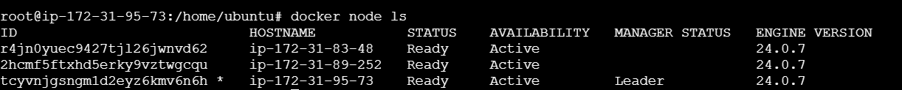

**Step 2: Deploy Apache Container with 4 Replicas**

1. **Create a service on the manager node** to deploy the Apache container:

**docker service create --name apache --replicas 4 -p 80:80 httpd:latest**

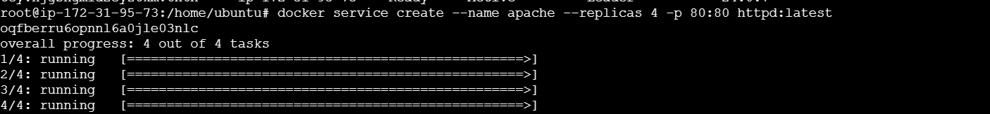

1. Verify the service is running:

**docker service ls**



1. Verify that the Apache containers are distributed across the nodes:

**docker service ps apache**



**Step 3: Access the Apache Service**

1. **Get the public IP** of any of your EC2 instances and open it in a browser.

**http://3.87.68.190/**



That's it! You now have a 3-node Docker Swarm cluster with an Apache container running with 4 replicas on AWS EC2.